May 2017 Events at West Los Angeles Branch Library
11360 Santa Monica Blvd., Los Angeles, CA 90025
310-575-8323

Memory Workshop:
May, 4, 11, 18, & 25
10:00am to 12:00pm
Space is limited, so please register in advance by calling 310-575-8323.
Description: Start the new year of 2017 right by joining us here at the West L.A. Regional Branch as we partner with Wise & Healthy Aging (www.wiseandhealthyaging.org) and trained workshop leaders from the UCLA Memory Program to facilitate a four-part, Memory Training workshop.
ABOUT THE PROGRAM:
Four Free workshops that meet for two-hours per week for four weeks
Developed by neuroscientists from UCLA
Intended for older adults who are concerned about their memory
This program is not suitable for people already with dementia or memory loss.
WORKSHOP TOPICS:
What to expect as we grow older
Different types of memory
Remembering lists
Name/ face recognition and "tip of the tongue."
SIGN-UP & REGISTRATION:
Registration for this series of four programs is required and can be done in person at the library or by calling 310-575-8323.

Teen Invention Program
Wednesday, May 03, 2017
4:00pm to 5:00pm
Audience: Teens
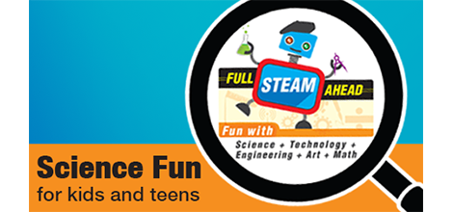

Description:
Have you ever seen inventors on TV or in the newspaper and thought, "That could be me!" Well, it certainly could - and author, Susan Casey, will show you how. Join us for this workshop and learn how to turn your ideas into realities for fun, competition, and even profit. Susan Casey, author of Kids Inventing! will teach you the ins and outs from finding an idea and creating a working model to patenting, manufacturing, and selling your invention. You’ll also learn how to prepare for invention contests and science fairs.

ARTBOT Robotics Workshop:
6, May, 2017 · 2:30 PM - 3:30 PM
For children, teens & families ages 7+
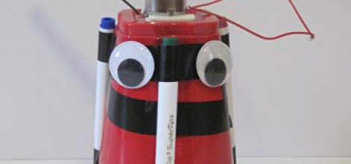
Description:
Create a simple, vibrating robot that skitters around on marker legs and leaves a colorful trail of art behind. Learn how to construct a simple circuit (battery, motor, switch); learn about voltage, current and power; learn what a short circuit is and how to avoid it.
Please RSVP at 310-575-8323

Artists at Play: Staged Reading
Saturday, May 13, 2017
2:00pm to 3:00pm
Audience:
Adults, Seniors, Teens
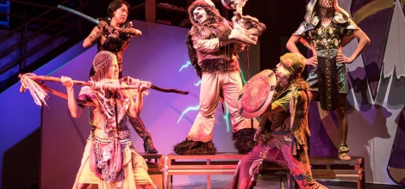
Description:
"Artists at Play" will perform tot: THE UNTOLD, YET SPECTACULAR STORY OF (a Filipino) HULK HOGAN by Victor Maog
Synopsis: tot follows an immigrant boy who travels from the Ferdinand Marcos-ruled Philippines to the San Francisco Bay Area to meet his long-lost parents. He journeys from a country full of strife and military rule only to find himself in his lonely American bedroom conjuring a pro wrestling fantasy to escape his new life.

"Artists at Play" is a collective of Asian-American creative professionals who curate quality theatre in Los Angeles. "Artists at Play" presents theatrical productions missing from Los Angeles’ local landscape to tell the stories of communities underrepresented in theatre, with a focus on the Asian-American experience.

Toddler / Preschool Storytime:
Wednesday mornings at 10:00 AM
Enjoy stories, songs and fingerplays for children ages 18-months to 5 years old.

Toddler / Preschool Storytime:
Thursday afternoons at 4:15 PM
Enjoy stories, songs and fingerplays for children ages 18-months to 5 years old.

